BIT3208
Advanced Web Design and Development

Practical Logbook — Weeks 1 to 5

Student Name | GABRIEL MANKA
Admission Number | _BSCCS/2024/56458
Course | Computer Science
Unit Code | BIT3208
Unit Name | Advanced Web Design and Development
Lecturer Name | _Michael Nyoro
Semester / Year | __2 year 3_________________________
Project Details
Project Title | __CARHIRE SYSTEM_________________________
Selected Technologies | PHP + MySQL + JavaScript (XAMPP)
Academic Year | Academic Year

Table of Contents

1. Project Details
2. Week 1 – Installation and Testing of Local Development Environment
3. 1.2 Tools & Apps Used
4. 1.4 Evidence (Screenshots)
5. Student Reflection – Week 1
6. Week 2 – User Interface Planning and System Design
7. 2.2 Tools & Apps Used
8. 2.4 Evidence (Wireframes & GUI Design)
9. Student Reflection – Week 2
10. Week 3 – Frontend Interaction and Backend Foundations
11. 3.4 Evidence (Screenshots)
12. Student Reflection – Week 3
13. Week 4 – Backend Form Processing, Authentication and Sessions
14. 4.4 Evidence (Screenshots)
15. Student Reflection – Week 4
16. Week 5 – Database CRUD Operations and Full System Integration
17. 5.4 Evidence (Screenshots)
18. Student Reflection – Week 5
19. End of Logbook

Week 1 — Installation and Testing of Local Development Environment

1.2 Tools & Apps Used
Tool / App | Purpose
XAMPP v8.x | Local server bundle — Apache, MySQL, PHP, phpMyAdmin
VS Code | Source code editor with PHP Intelephense extension
Google Chrome | Browser for testing localhost pages
phpMyAdmin | Web-based MySQL database manager (bundled with XAMPP)
Git + GitHub | Version control and cloud backup

1.4 Evidence (Screenshots)
Fig 1: XAMPP Installation Success
[ I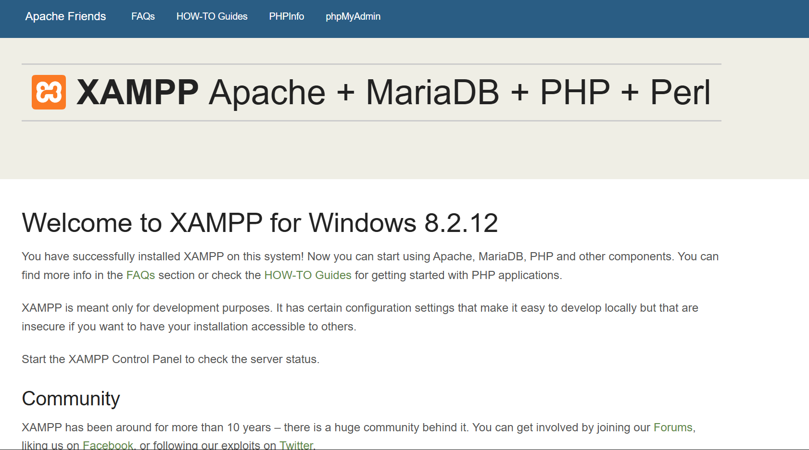NSERT SCREENSHOT HERE ]
Screenshot showing the XAMPP setup wizard completing successfully with all components installed.

Fig 2: Apache and MySQL Running in XAMPP Control Panel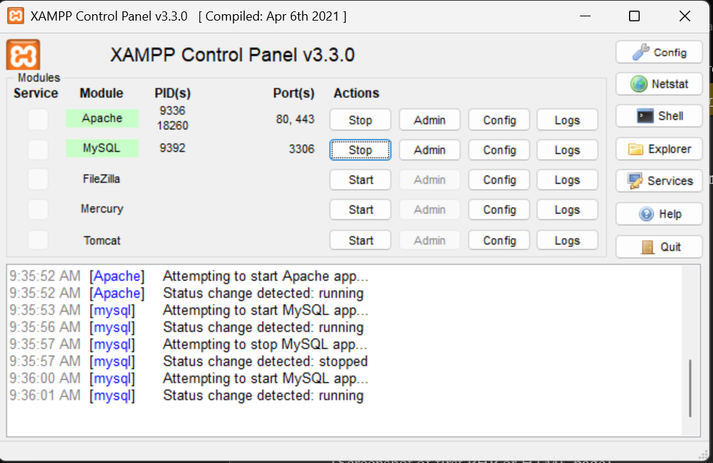

Fig 3: Localhost Test Page in Browser
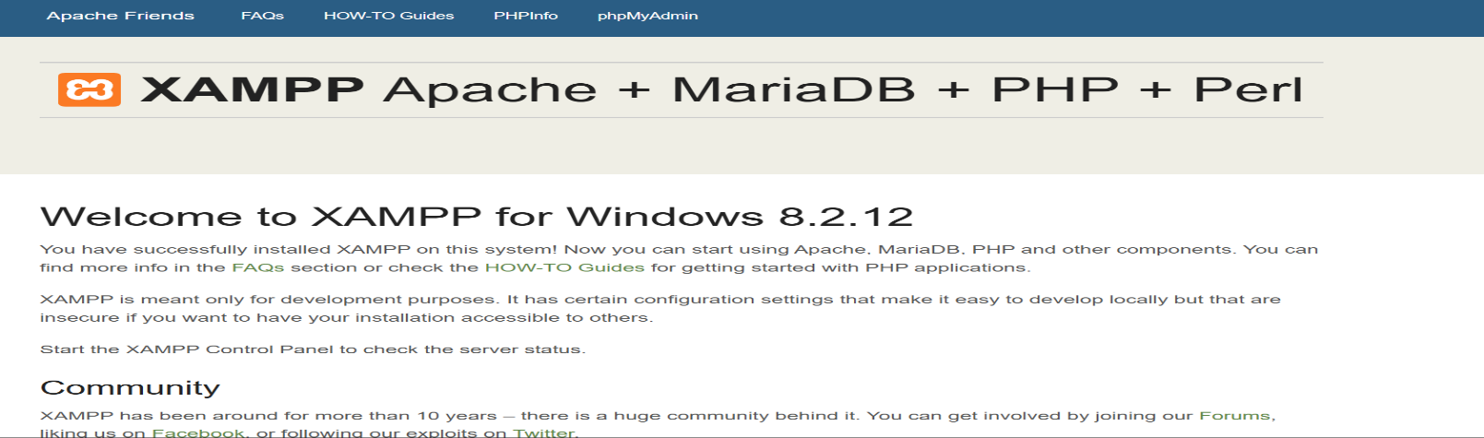

Fig 4: Hello Word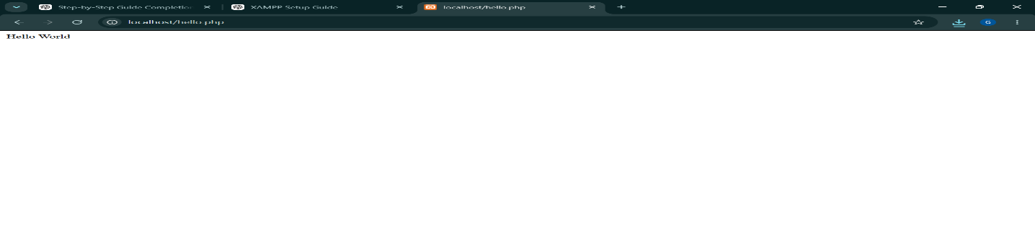

Fig 5: Successful Database Connection via PHP
[ INSERT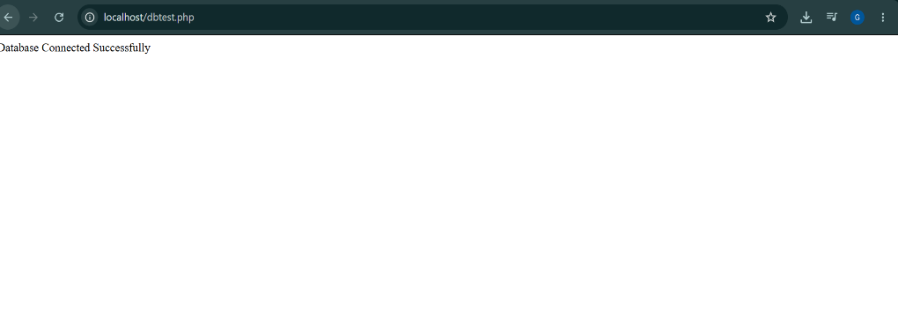

Student Reflection
This week I set up my local development environment using XAMPP, which bundles Apache, MySQL, and PHP into a single installer. I learned how Apache serves PHP files and how mysqli_connect() links PHP to a MySQL database.

Week 2 — User Interface Planning and System Design

2.1 Objectives
- Create hand-drawn wireframes for all main system pages
- Design a digital GUI prototype using Figma
- Build HTML/CSS layouts matching the wireframe designs
- Plan the project workflow and select the technology stack

2.2 Tools & Apps Used
Tool / App | Purpose
Figma (figma.com) | Digital wireframing and GUI prototype design — free browser-based tool
VS Code | Writing HTML and CSS layout files
Chrome DevTools | Testing responsive layout (F12 → Toggle Device Toolbar)
Draw.io (draw.io) | Alternative for flowcharts and system diagrams
Canva (canva.com) | Optional — colour palette and design inspiration

2.4 Evidence
Fig 1: Hand-Drawn Wireframe — Login Page
[ I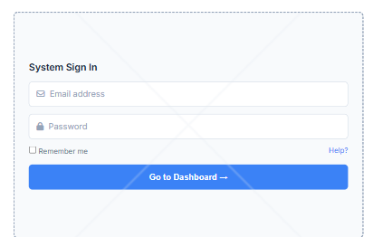

Fig 2: Dashboard Layout Design in Figma
[ INSERT S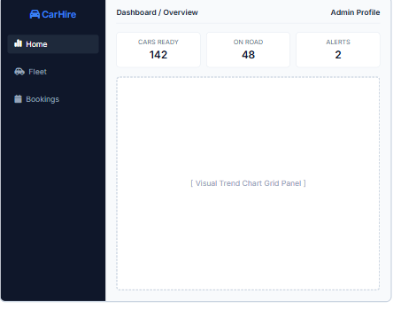

Fig 3: Mobile View Mockup (Chrome DevTools)
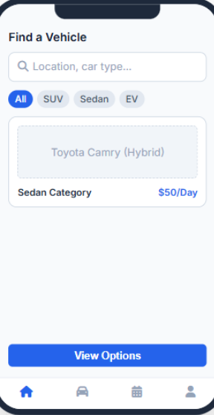

Fig 4: Color Theme and Navigation Structure
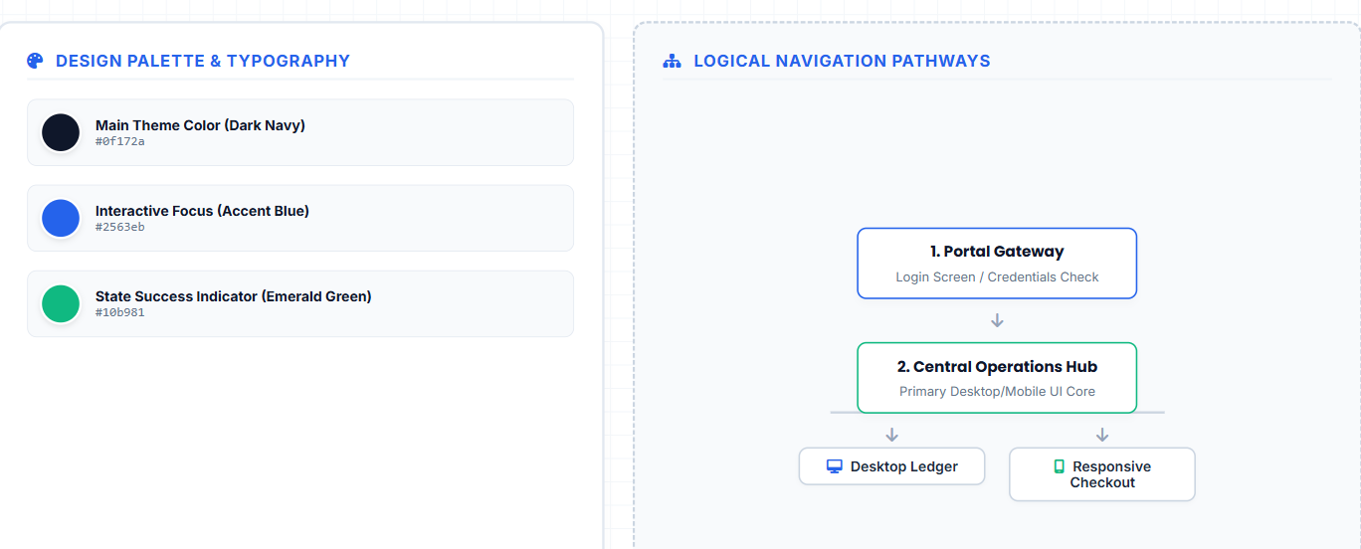

Fig 5: Live GUI Prototype in Browser
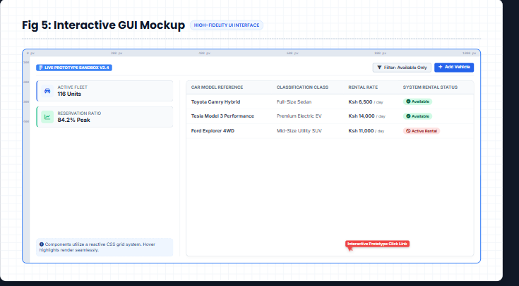

Student Reflection (max 100 words)
Week 2 focused on planning the system visually before writing backend code. Figma allowed me to experiment with layout and navigation flow without touching any PHP.

Week 3 — Frontend Interaction and Backend Foundations

3.4 Evidence (Screenshots)
Fig 1: JavaScript Form Validation — Error Messages
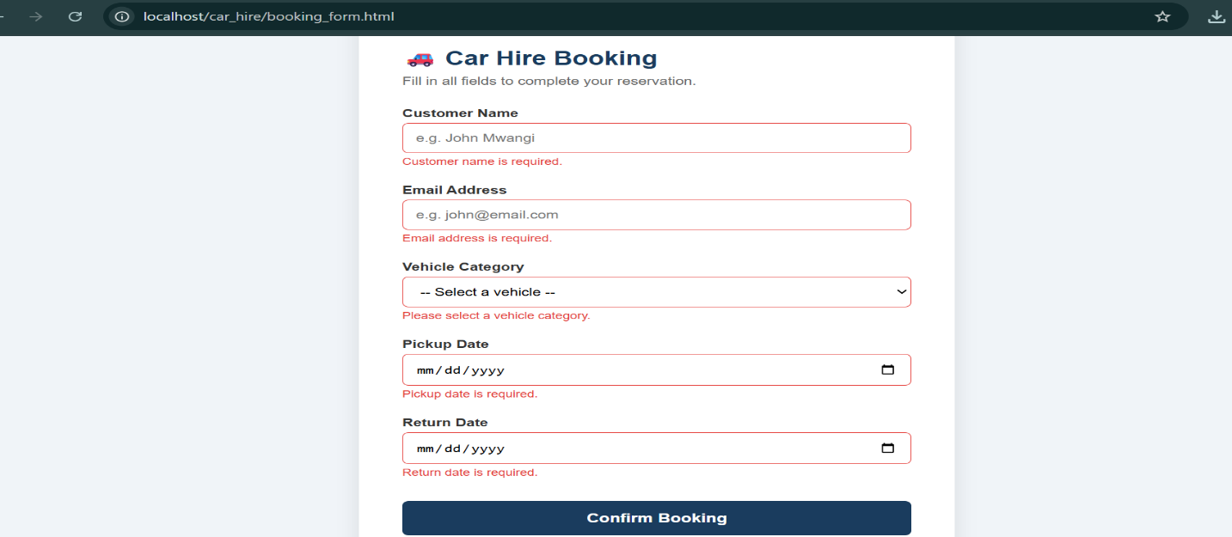

Fig 2: Password Strength Checker in Action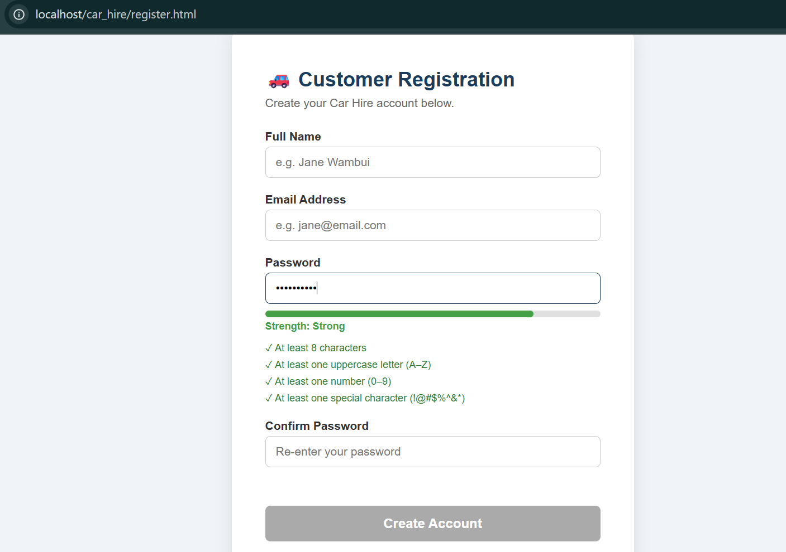

Fig 3: PHP Syntax Practice Output
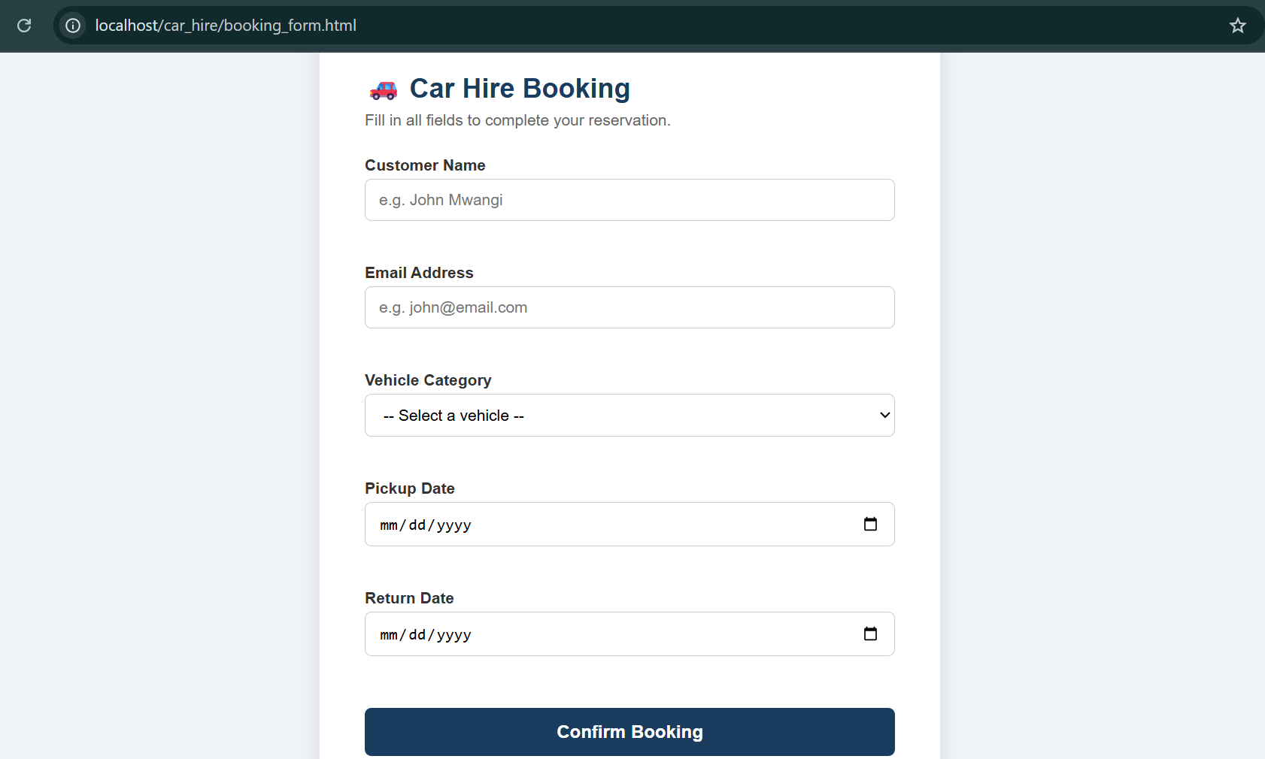

Fig 4: Database Connection Script — Success
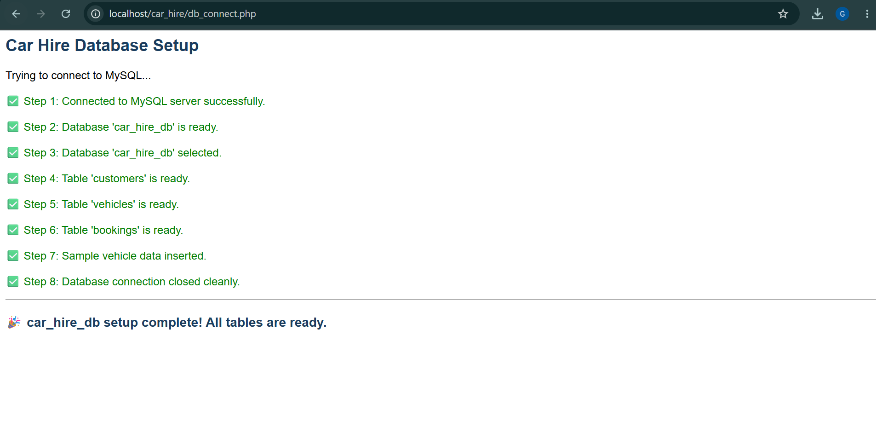ct() worked.

Fig 5: Dynamic User Input Handling via DOM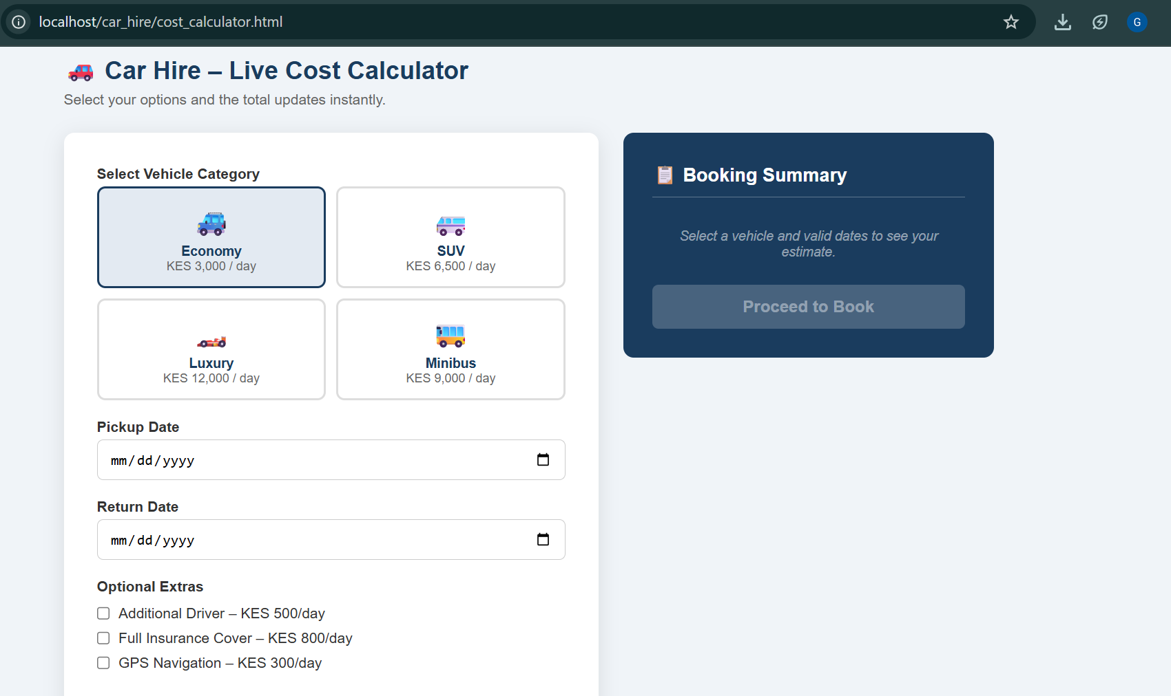

Student Reflection (max 100 words)
Week 3 bridged the gap between static HTML and interactive web pages. JavaScript validation prevents invalid data from reaching the server, reducing PHP processing errors. The password strength checker demonstrated real-time DOM updates using event listeners.

Week 4 — Backend Form Processing, Authentication, and Sessions

4.4 Evidence (Screenshots)
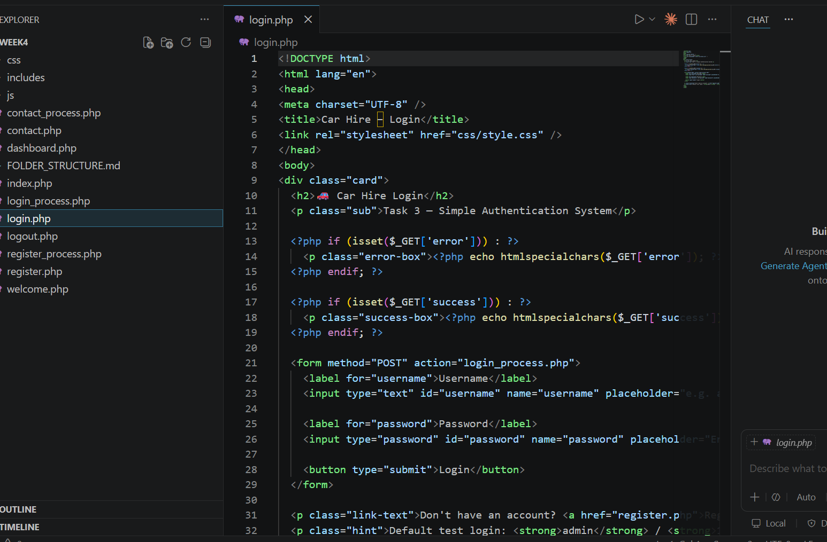
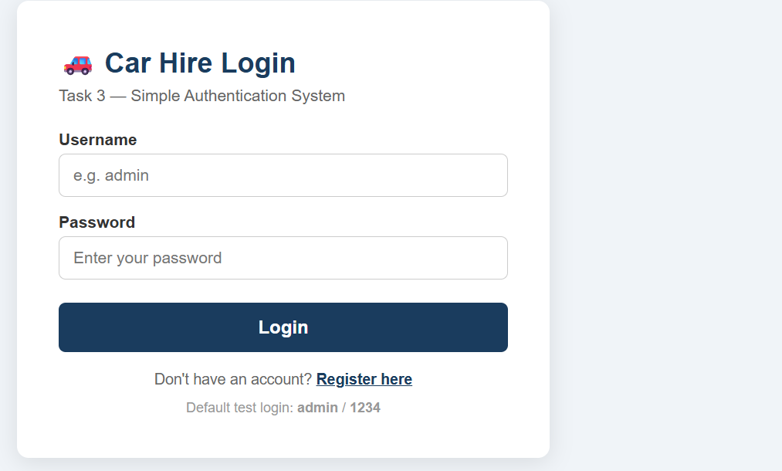

Fig 2: Invalid Login — Error Message
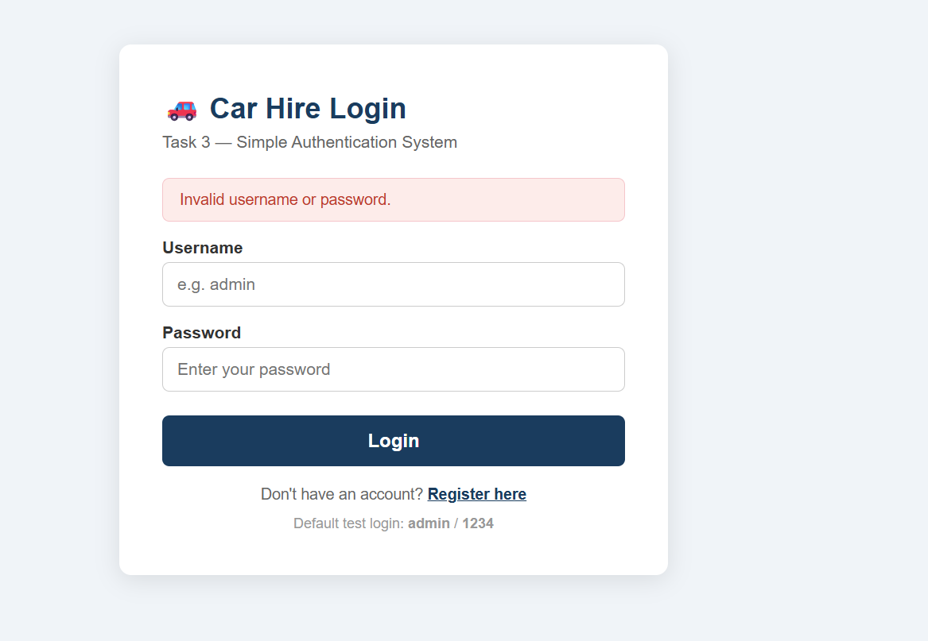

Fig 3: Successful Login — Dashboard with Session Username
[ INS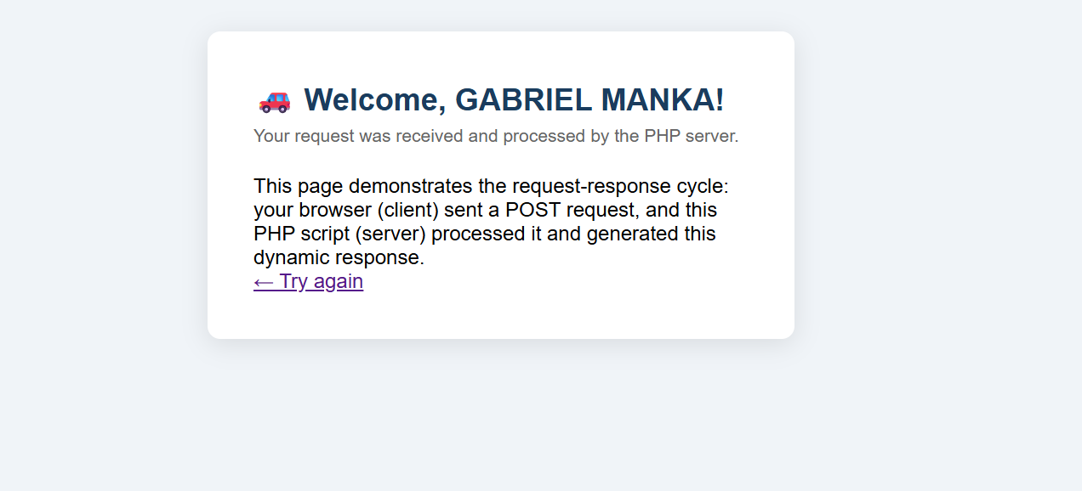

Fig 4: Session Cookie in Chrome DevTools
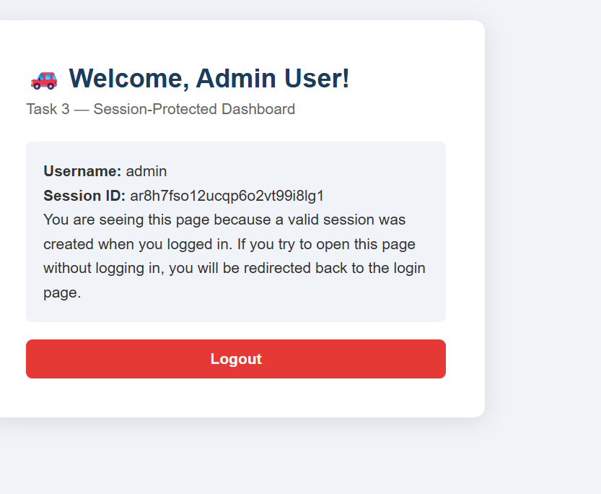

Fig 5: Logout — Redirected Back to Login

Browser showing 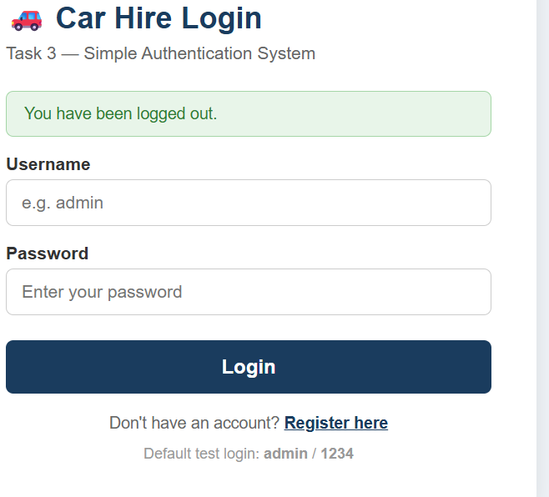

Fig 6: Professional Folder Structure in VS Code
[ INS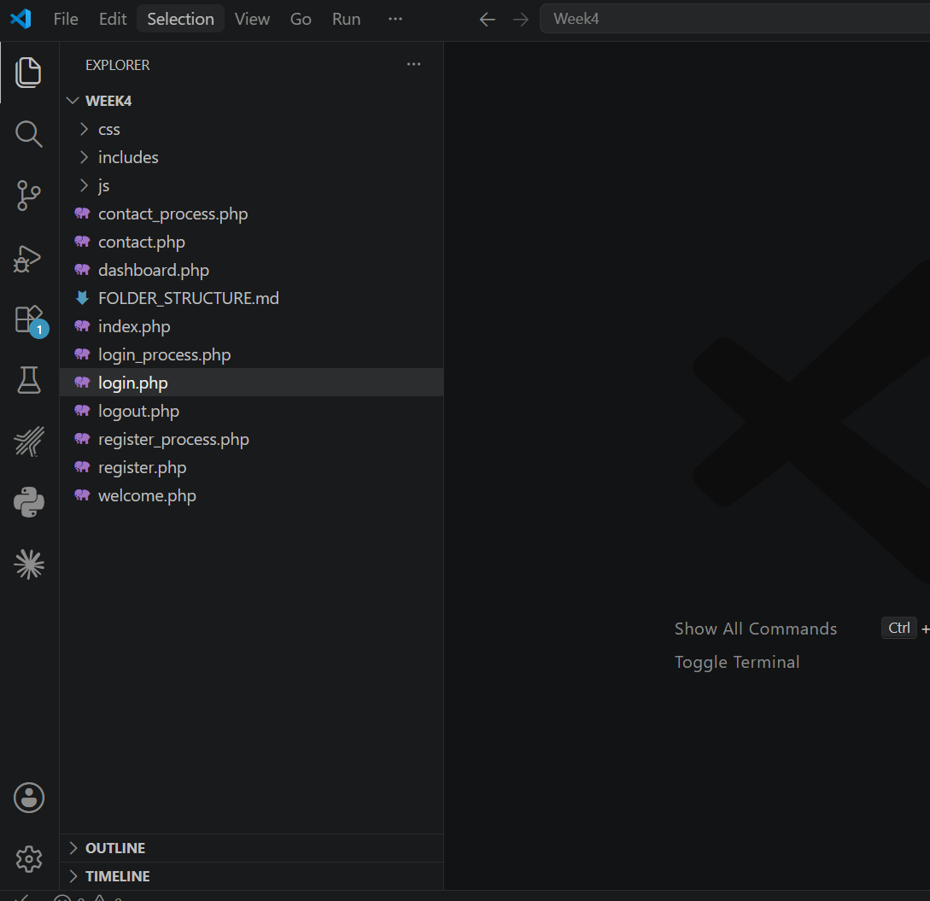

Student Reflection (max 100 words)
Week 4 introduced server-side processing and state management using PHP sessions. The key learning was that HTTP is stateless — sessions solve this by storing user data on the server between page loads.

Week 5 — Database CRUD Operations and Full System Integration

5.4 Evidence (Screenshots)
Fig 1: Database and Table Creation in phpMyAdmin
[ INSERT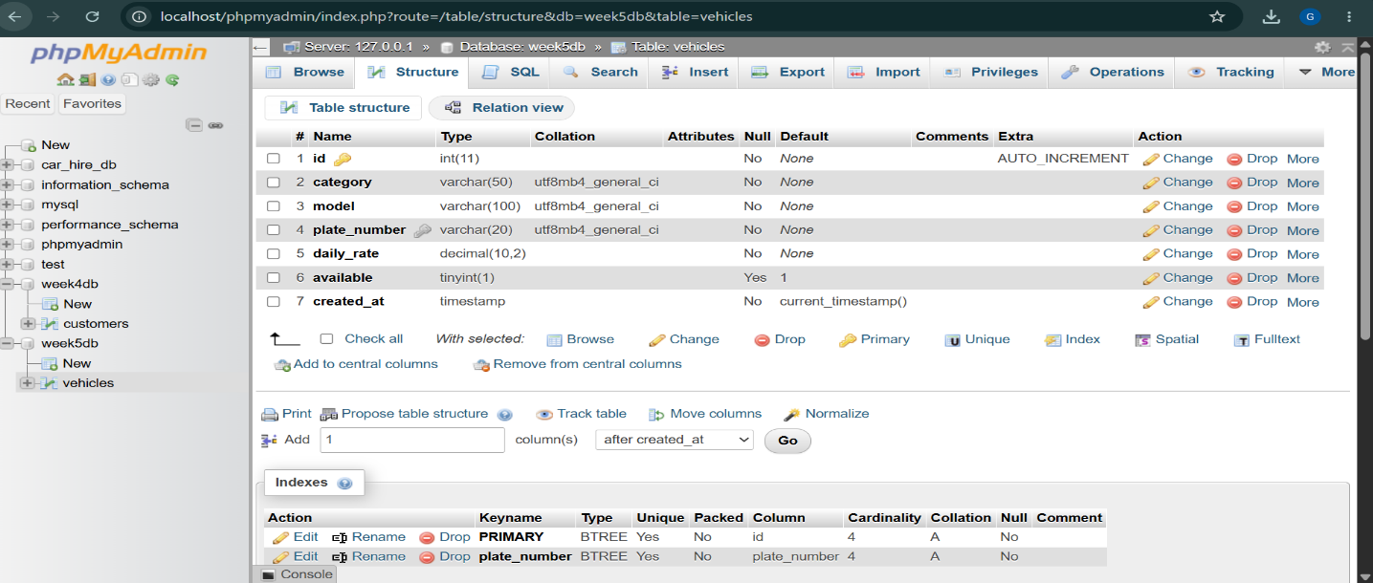

Fig 2: Registration Form — New User Saved to Database
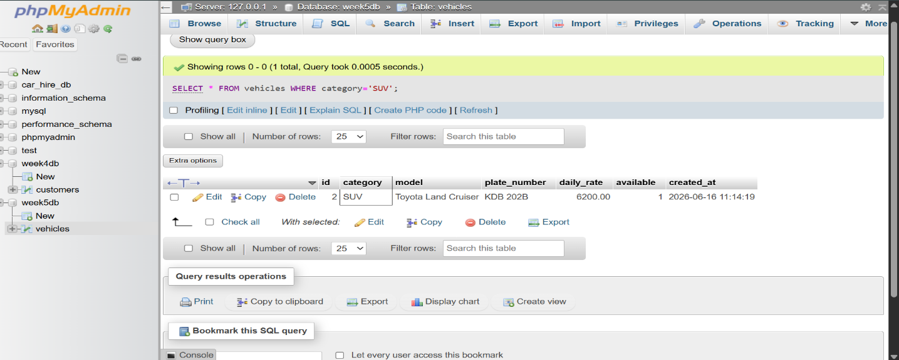

Fig 3: Login Using Database Credentials
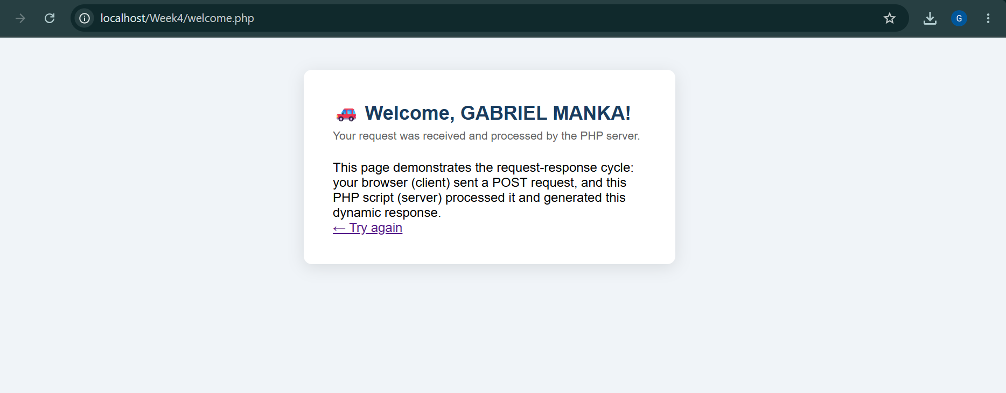

Fig 4: Dashboard — All Users Displayed in Table
[ I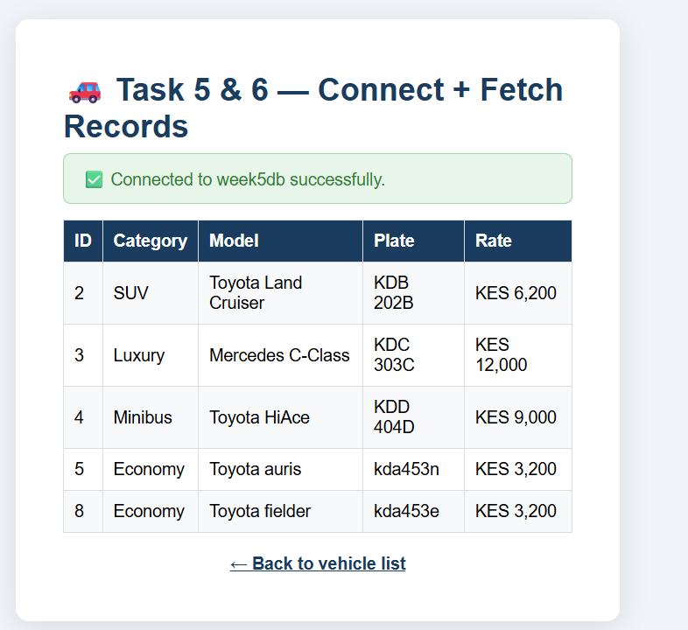

Fig 5: Edit User — Pre-filled Form and Update Confirmation
[ INSERT S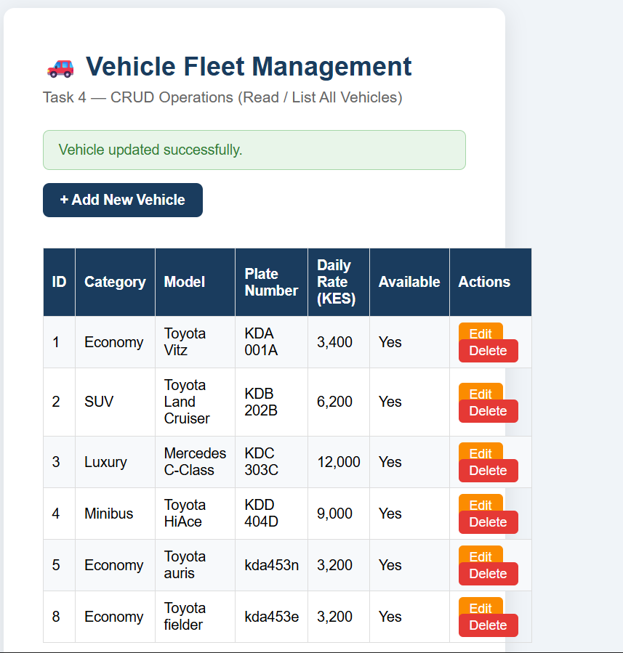

Fig 6: Delete User — Record Removed from Table
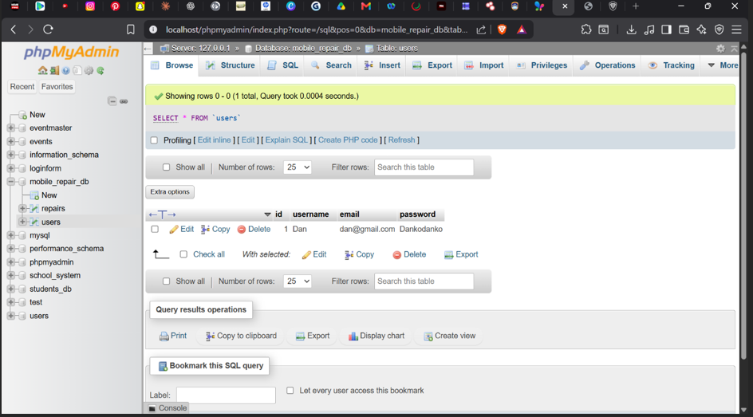

Fig 7: GitHub Repository — All Weekly Commits
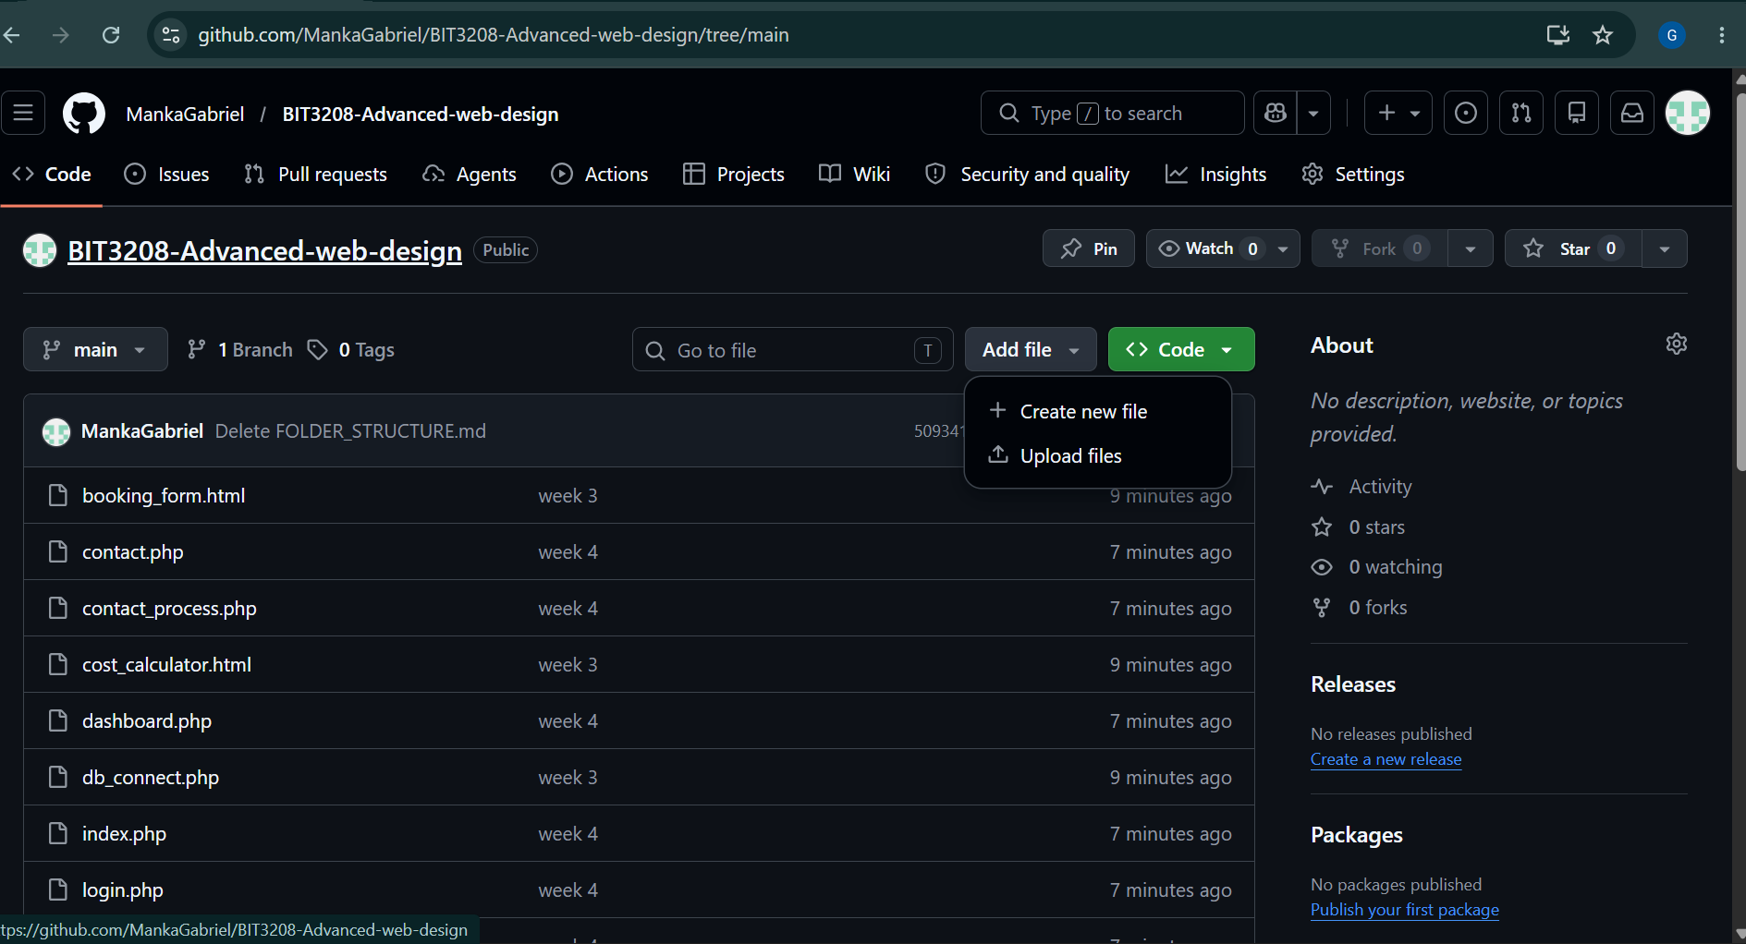

Student Reflection (max 100 words)
Week 5 completed the full CRUD cycle, making the system fully data-driven. The most important concept was the difference between SELECT (read-only) and INSERT/UPDATE/DELETE (write operations). Using password_hash() and password_verify() ensured passwords are never stored in plain text — a real security requirement. intval() on DELETE requests prevents SQL injection.

End of Logbook — BIT3208 Advanced Web Design and Development

